|  |  |
| --- | --- |
| **TIMESHEET**  **PROCEDURES**  **For Supervisors**  **&**  **Participants**  Timesheets are a legally required  document. Employers have to **keep accurate records of** employee work hours as part of the requirements for recordkeeping from the Federal Law. | How Many Workweeks in a Year - How I Got The Job  **ABSTRACT**  Timesheets must be signed by both the Participant and the Host Agency Supervisor. It is the responsibility of the Participant to submit the timesheet to the Host Agency Supervisor at a previously identified time/date for each pay period as noted on the Payroll Schedule  **Paul Preston,**  **Controller**  **Deborah Delman**  **SCSEP Director**  **Patricia Johnson,**  **Payroll Specialist & Accounting Assistant**  **William Nadler**  **Documentation Specialist** |

This Page Intentionally Blank

Our host agencies are an integral part of our effort to conscientiously and accurately spend and account for the taxpayer dollars that pay the participants for the time they train in your agency.

The money earned by our participants for the time they spend training in your agency is critical to their well-being. The timesheets you fill out and submit are the legal and auditable record of that spending. As such, the clean, accurate and timely submission of each timesheet in each pay period is the critical component in the chain of control for this money—and it means your very low-income participant(s) will not miss a meal or a rental payment because they don’t have any money in their pocket.

Timesheets will be available for the participants by the SCSEP Sponsor, Operation ABLE. Blank timesheets for each payroll period and a blank Individual Progress Report (IPR) may be downloaded from our [www.operationable.net](http://www.operationable.net/) website.

Host agency supervisors will assure that timesheets are:

* Completed on time by the participant
* Verified to be accurate by the host agency supervisor
* Signed by both participant and supervisor
* Faxed and mailed at the end of the pay period to the SCSEP Sponsor issuing checks

|  |  |
| --- | --- |
| Participants may download a blank current and previous period timesheet from the Operation ABLE timesheet page of our[www.operationable.net](http://www.operationable.net)website. A blank Individual Progress Report (IPR), Participant Handbook, Participant Grievance Policy & Guidelines and Timesheet Instructions are also available on our website. | |
|  | | | |
| Original time sheets are to be e-mailed or faxed to the SCSEP Sponsor, Operation ABLE within the timeframe determined by the SCSEP Sponsor.  A copy should be kept on file by the host agency.  Host agency supervisors will assure that timesheets are:  ✓ Completed on time by the participant  ✓ Verified to be accurate by the host agency supervisor  ✓ Signed by both participant and supervisor  ✓ Faxed and mailed at the end of the pay period to the SCSEP Sponsor issuing checks |  | |

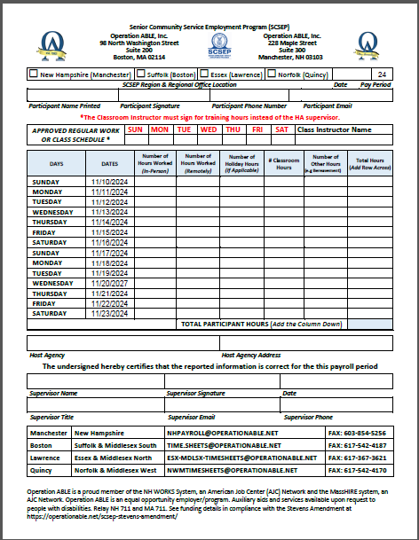

**#9**

**#8**

**#7**

1. Enter a check mark in the appropriate regional office box.
2. Enter today’s date
3. Enter your full Participant Name, your Signature, your Phone Number, and your Email
4. Enter the approved Work Schedule Days. If not working, enter the Classroom Training Days.
5. Fill in the Days and Hours the you are Authorized to Work in the Corresponding Day Columns for Week 1
6. Fill in the Days and Hours the you are Authorized to Work in the Corresponding Day columns for Week 2
7. The Participant Total Paid Hours
8. Host Agency Name, and Street Address
9. Submit to your Supervisor for their Name, Signature and Approval Date
10. Your Supervisor’s Title, Email and Phone Number
11. Email or FAX to the correct regional office

**#2**

**#1**

**#3**

**#4**

**#5**

**#6**

**#10**

**#11**

The host agency supervisor is the direct supervisor for the participant’s ongoing assignment, monitors the participant’s day-to-day activities, and will train as well as give feedback about performance. The supervisor or a designated alternate must provide supervision coverage at the site at all times. In the event of the absence of the participant’s direct supervisor, a simple written plan for backup supervision shall exist and be provided to the SCSEP staff. A participant must know whom they are to report to at all times. Any change of supervisor must be reported to the SCSEP staff. The same level of supervision and training provided to regular employees performing related tasks at the agency should also be provided to SCSEP participants. Training and supervision will prepare the participant for the transition to unsubsidized employment.

Provide additional support to SCSEP by promoting the program with peers and employers in the community, co-sponsoring special events, or providing in-kind or direct support to the program.

## The Supervisor’s Role in the Timesheet Process

1. It is the responsibility of the Host Agency Supervisor to verify that Time Sheets are filled out correctly and that the hours and days reported reflect the actual hours that the Participant was on the assignment. Participants may not “bank” hours; Participants may make up missed hours during the same two-week pay period, ONLY. Participants may report no more than 40 hours in any one week on a time sheet and no more than 40 hours for any two-week payroll period. Working extra hours not approved by the SPONSOR, can be cause for termination of the Participant and cancellation of the Host Agency Agreement.
2. Time sheets may only be signed by Supervisor(s) who are on the Supervision Report and have signed the Authorized Signature Form.
3. Ensure that any required edits are corrected in a timely manner
4. Confirm that the timesheet is submitted to each regional office by the deadline
5. Make certain that the respective regional office is notified when the participant is absent
6. Notify the respective regional office when your agency is closed

The Host Agency agrees to provide documentation of in-kind contributions. Further, it is understood by the Host Agency and the Sponsor Agency that any contribution, whether cash or in-kind, by the Host Agency is purely voluntary and is not a condition for the assignment of any participant.

Host Agency In-kind Supervision Report The Host Agency In-kind Supervision Report is to be completed at least quarterly (preferably with each bi-weekly participant timesheet) to gather the wage information for all host agency staff members who will be directly supervising SCSEP participants. The information gathered on this form is strictly confidential and is used only by the local SCSEP finance department for the purpose of calculating the in-kind contribution amount that your organization contributes to SCSEP.